Design and simulation of a broadband tunable transmittance optical filter using Sb₂Se₃ phase change material
Chettanat Padungatthakij,^{1,†} Prathan Buranasiri,^{1,2,†} Suebtarkul Suchat,³ and Surawut Wicharn^{4,*}
¹Artificial Intelligence Photonics Advanced Research Laboratory, Department of Physics, School of Science, King Mongkut’s Institute of Technology Ladkrabang, Bangkok 10520, Thailand
²Electronic and Optoelectronic Device Research Unit, School of Science, King Mongkut’s Institute of Technology Ladkrabang, Bangkok 10520, Thailand
³Department of Physics, Faculty of Science and Technology, Phranakhon Rajabhat University, Bangkok 10220, Thailand
⁴Department of Physics, Faculty of Science, Srinakharinwirot University, Bangkok 10110, Thailand
†These authors contributed equally.
*surawutw@g.swu.ac.th
Abstract: We propose a switchable transmittance filter that operates around 1064 nm wavelengths using antimony triselenide (Sb₂Se₃). Sb₂Se₃ is a phase change material (PCM) that has low absorption in the infrared (IR) spectrum, large and stable refractive index contrast between the two phases, and high optical endurance of ~10⁶ cycles. We provide the reasoning for selecting a long-pass edge-filter design and compare its performance to other planar thin-film designs. At 1064-nm, the selected 5-unit-cell edge-filter design has 93.6% transmittance in amorphous phase and 0.2% in crystalline phase, a 93.4% transmittance contrast with ~200 nm FWHM. It has minimal transmittance degradation after enduring over 1.5×10⁶ phase switching cycles. We show the transmittance tunability of the design by changing the phase of each Sb₂Se₃ layer, and each layer thickness can be optimized to increase the optical performance across the 900-1200 nm wavelengths.
- Introduction
The term phase change material (PCM) can have different meanings depending on the research field. In energy storage, the term refers to materials that store and release thermal energy through changes in their state of matter (latent heat), such as between solid and liquid states [1]. However, in electronics and photonics, the term phase change material refers to a solid-state material that changes its crystal phase when its temperature rises above the transition temperature (T_{trans}). This change leads to a contrast of complex refractive index ñ between the initial and post-transitioned phases, where ñ = n + ik comprises of the real refractive index n and the imaginary extinction coefficient k [2]. The refractive index contrast between the two phases is an order of magnitude larger than the contrast caused by an applied electric field or light intensity (Kerr effect) [3], which makes PCM ideal for photonic applications that require the modulation of optical performance. Examples include reconfigurable metasurfaces [2, 4-6], optical limiters [3, 7-9], optical switches [10, 11], optical filters [12-15], and absorbers [16, 17].
A phase change material can be classified based on its behavior after phase transition. A volatile PCM reverts to its pre-transitioned phase when the temperature falls below T_{trans}. However, a non-volatile PCM will transition from amorphous to crystalline phase and remains in crystalline phase even if the temperature falls below T_{trans}. To revert its phase back, it needs to be melted and then rapidly quenched into amorphous phase, where the quenching speed needs to be fast enough such that PCM atoms don’t have time to form a crystalline lattice. An example of volatile PCM is vanadium dioxide (VO₂), which in the past 10 years has gathered attention as a volatile PCM with T_{trans} closest to room temperature at 68 °C. It also has a relatively large refractive index contrast in the infrared with a small extinction coefficient k in the insulating phase (cold state). However, k increases when transitioned to the metallic phase (hot state) [8, 9]. Two examples of non-volatile PCMs are chalcogenide glasses, Ge₂Sb₂Te₅ (GST) and Ge₂Sb₂Se₄Te (GSST). GST was one of the earliest and most studied PCMs [18]. It has a large refractive index contrast between amorphous and crystalline phases, and low T_{trans} when compared to other non-volatile PCMs, where T_{trans} ~145 °C for the cubical phase, and T_{trans} ~200 °C for the hexagonal phase [3, 19]. A drawback is its large extinction coefficient in both the visible and infrared (IR) spectra, which causes high optical loss from absorption. Meanwhile, GSST (Ge₂Sb₂Se₄Te₁), which is a derivative of GST that substitutes some part of tellurium with selenium, also has a large refractive index contrast but a lower extinction coefficiency, which helps increase the optical efficiency. However, GSST has a higher T_{trans} of ~242 °C [19].
Initial research on Antimony triselenide (Sb₂Se₃) was in solar-energy applications, while its usage as a PCM in photonic applications is relatively recent. It is non-volatile, has near-zero absorption in NIR and IR wavelengths, large and stable refractive index contrast from visible to IR, and a transition temperature that is between GST and GSST at ~186 °C [20, 21]. In addition, Sb₂Se₃ has a fast phase-switching speed in the microsecond range [18, 21, 22], and its phase-switching endurance is also high, with experimental demonstrations showing that it can reach as high as 10⁶ to 10⁷ cycles [21, 22]. These properties make Sb₂Se₃ an attractive material for high-efficiency reconfigurable optical switches and optical circuits that can be used in optical waveguides [4-6, 11, 14, 18], or an optical filters [14, 15].
The transmittance of an optical filter can be modulated by the changes in refractive index of PCM. The ON mode has high transmission by creating antireflection condition and minimizing the absorption from the filter, and OFF mode has low transmission after phase transition. The methods for phase transition can be via absorption of high-intensity laser or from direct heating of PCM layers (Joule heating) [12]. The former method is similar to the behavior of optical limiters but is not suitable for Sb₂Se₃ since it has very small extinction coefficients in both phase at IR wavelengths. So direct heating or heating via a different wavelength of light, such as visible spectrum [21], is preferred. The designs can be planar thin-film structures or metasurfaces; planar structures are easier to design, optimize, and fabricate, while metasurfaces offer higher design flexibility [8]. For planar designs, there are many methods for creating antireflection condition, such as single-layer or multilayer antireflection designs, line-pass filters, or Fabry–Pérot resonant cavities [23].
In this work, we investigate Sb₂Se₃ as a PCM in planar thin-film designs for transmittance tunable optical filters. The operating wavelength is selected to be 1064 nm, Nd:YAG laser wavelength which is commonly used in laboratory setups. At this wavelength, Sb₂Se₃ exhibits zero absorption in the amorphous phase and near-zero absorption in the crystalline phase, and its refractive index contrast is high and stable throughout the IR spectrum. The goal is to create a low-loss, broadband transmittance-tunable optical filter.
- Theories
2.1 Optical properties of Sb₂Se₃
Antimony triselenide (Sb₂Se₃) is an orthorhombic chalcogenide non-volatile phase change material (PCM) characterized by quasi-one-dimensional ribbons. While its amorphous phase consists of a disordered network of distorted motifs, crystallization restores long-range order along the ribbon direction. This thermally driven transition can be triggered by nanosecond to microsecond optical or electrical pulses [18, 21]. The process is reversible and has high endurance, with optical switching reaching 10⁶ to 10⁷ cycles [21, 22]. As an optical device, Sb₂Se₃ enables repeatable toggling between high and low transmission modes, provided that local heating remains below the melting or ablation threshold [4, 22].
The complex refractive index ñ of any phase change material at wavelength λ is:
${\tilde{n}}_{p}\left(λ\right)=n_{p}\left(λ\right)+ik_{p}\left(λ\right)$ (1)
where p denotes the phase of Sb₂Se₃ which can be either amorphous (amo) or crystalline (cry) phase. Dispersive models, such as Tauc-Lorentz or multi-oscillator fits are often used to represent the measured n_{p} and k_{p} over the spectral range of interest. However, in this work, linear interpolation is used because all the datasets used have measurement interval of less than 4 nm. Figure 1 shows their complex refractive indices from 300 to 1700 nm using the dataset from Delaney, et al. [18], where the complex refractive indices at 1064 nm are ñ_{amo} = 3.370 + 0.000i and ñ_{cry} = 4.308 + 0.010i. The blue lines represent real refractive index (n) and the red lines represent imaginary extinction coefficient (k). In amorphous phase, the refractive index increases from ~2.4 at 300 nm to a peak of ~4.0 at 600 nm and gradually decreases to a stable value of ~3.3 above 1200 nm, indicating a strong dispersion near the band edge of visible spectrum and a weaker dispersion in the NIR spectrum. The extinction coefficient starts from ~2.1 at 300 nm and drops to zero at ~850 nm. In the crystalline phase, the refractive index at the UV wavelengths is around the same value as the amorphous phase but reaches a higher peak of ~5.1 at around 660 nm; it then drops to a stable value of ~4.1 in the NIR spectrum. The absorption index of crystalline phase peaks at ~3.1 in the near-UV spectrum and rapidly approaches zero above 900 nm.
The refractive index contrasts (Δn = n_{c} - n_{a}) are large and stable from the visible through IR spectra, and the extinction coefficients are large in the near-UV region but fall to zero around the NIR spectrum for both phases, with the crystalline phase exhibiting higher absorption in the visible spectrum. Thus, when compared to other PCMs, Sb₂Se₃ has several advantages when operating in the NIR and IR wavelengths. The large Δn and low k starting from NIR wavelengths enable a device to operate in two modes with little to no optical loss, and a stable Δn also helps with broadband designs.

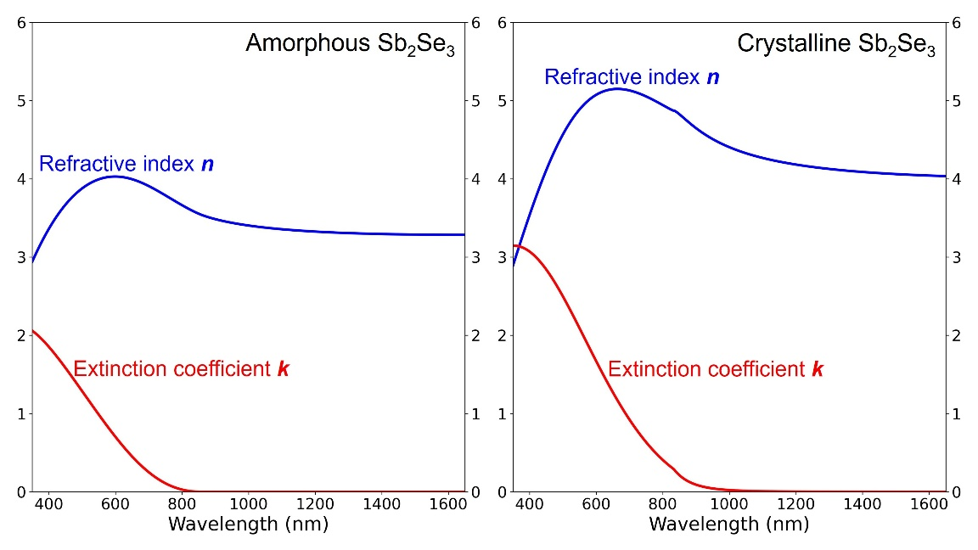
Fig. 1. Complex refractive index of Sb₂Se₃. Graphs are plotted from experimental data of [18].

2.2 Single-layer antireflection design
The goal of designing most optical devices is to either create antireflection or high-reflection conditions. For a two-mode optical device, such as a transmittance tunable filter, we can consider the reflection in the ON mode first, and then the reflectance contrast ΔR between the ON and OFF modes. The simplest antireflection from a planar thin-film design is one film layer deposited on top of a substrate; both the film and the substrate should have zero absorption. The diagram in the top right corner of Fig. 2 shows that a single-layer film reflects light at two interfaces: the bottom interface between the film and substrate (R₁) and the top interface between the air and film (R₂). Antireflection occurs from the destructive interference between R₁ and R₂, with a complete AR condition requiring the same amplitude and a phase difference of π radian (optical path length of λ/2). Because R₁ propagates through the thin film layer twice (while transmitted down and reflected backup), the optical thickness (OT) of the film only needs to be equal to half of the optical path length, OT = λ/4, this also known as quarter-wave optical thickness (QWOT). The optical thickness is related to the physical thickness t by the following equation:
$OT(λ)=n(λ) t$, (2)
where n(λ) is the refractive index of the film at λ. For a single-layer AR device, the thin-film physical thickness t must be
$t=\frac{OT}{n}=\frac{λ/4}{n}$. (3)
Another method for calculating the thickness required for the AR condition is to consider the reflection of the device. The reflectance R of only the substrate is related to the Fresnel coefficient r by
$R= {\left|r\right|}^{2}={\left|\frac{n_{a}-n_{s}}{n_{a}+n_{s}}\right|}^{2}$, (4)
where n_{a} is the air refractive index, and n_{s} is the refractive index of substrate. If a single-layer film is placed on top of a substrate, the film and substrate layers can be combined into an effective reflectance index n_{r} [23], defined as
$n_{r}=n_{f}\frac{\left(n_{s}+n_{f}\right)+\left(n_{s}-n_{f}\right)e^{-i2θ}}{\left(n_{s}+n_{f}\right)-\left(n_{s}-n_{f}\right)e^{-i2θ}}$, (5)
where n_{f} is the film refractive index, i is the imaginary unit, and θ is the phase thickness which is related to optical thickness and physical thickness t by the angular wavenumber k₀ = 2π/λ:
$θ=k_{0}OT=k_{0}nt$. (6)
By replacing n_{s} in Eq. 4 with n_{r} from Eq. 5, the reflectance of a single-layer device becomes:
$R={{\left|r\right|}^{2}=\left|\frac{n_{a}-n_{r}}{n_{a}+n_{r}}\right|}^{2}$. (7)
The antireflection condition happens when R = 0 or n_{r} = n_{a}. This condition occurs when the phase thickness θ is in multiple of π/2 radians:
$θ=Z\frac{π}{2}$, (8)
where Z denotes even integer. If this condition is satisfied, Eq. 5 can be simplified with Euler’s identity (exp^{-iπ} = -1) to:
$n_{r}=n_{f}\frac{\left(n_{s}+n_{f}\right)-\left(n_{s}-n_{f}\right)}{\left(n_{s}+n_{f}\right)+\left(n_{s}-n_{f}\right)}=\frac{n_{f}^{2}}{n_{s}}$. (9)
By substituting this into Eq. 7, the refractive indices for antireflection condition becomes:
$n_{a}n_{s}=n_{f}^{2}$. (10)
Another condition is the relative refractive index between the air, film, and substrate, which must be in the following order: n_{air} < n_{f} < n_{substrate}. Light shifts its phase by π radian when reflected from a lower to a higher refractive index medium. The reflected light at the air-film interface (R₂) will always undergo a π radian phase shift since n_{a} will be the lowest in most cases. Therefore, R₁ must undergo the same phase shift to create destructive interference.
These two conditions limit material selections for a perfect antireflection, since there is only one ideal refractive index (n_{ideal}) for each n_{s}. The refractive index of Sb₂Se₃ is higher than that of substrate (silica; SiO₂) at every wavelength. So, if Sb₂Se₃ is QWOT, the reflection from R₁ still travels 2QWOT (π radian) further than R₂ but only R₂ has its phase shifted by π radian during reflection, so the two R’s have a phase difference of 0 radian, a constructive interference. To minimize reflection, the Sb₂Se₃ thickness can be increased to twice the QWOT (OT = λ/2), this is called half-wave optical thickness (HWOT) and is equivalent to an absentee layer. For example, at the reference wavelength λ₀ = 1064 nm, if we use 3-mm-thick SiO₂ as the substrate (n_{s} = 1.46) [24], the ideal QWOT-film thickness is calculated from Eq.10 to be n_{ideal} = 1.21. The material with the closest refractive index is MgF₂ (n_{MgF2} = 1.38) [25]. A slight difference from ideal value causes the reflection to be slightly higher, as illustrated in Fig. 2. The reflectance of the Sb₂Se₃ (blue) is the highest, at 6.5%, because the PCM layer is an absentee layer, so the reflection is equivalent to a standalone 3-mm SiO₂ substrate. An ideal film (red) still exhibits small reflectance because of the reflection in the substrate-air layer in the back.

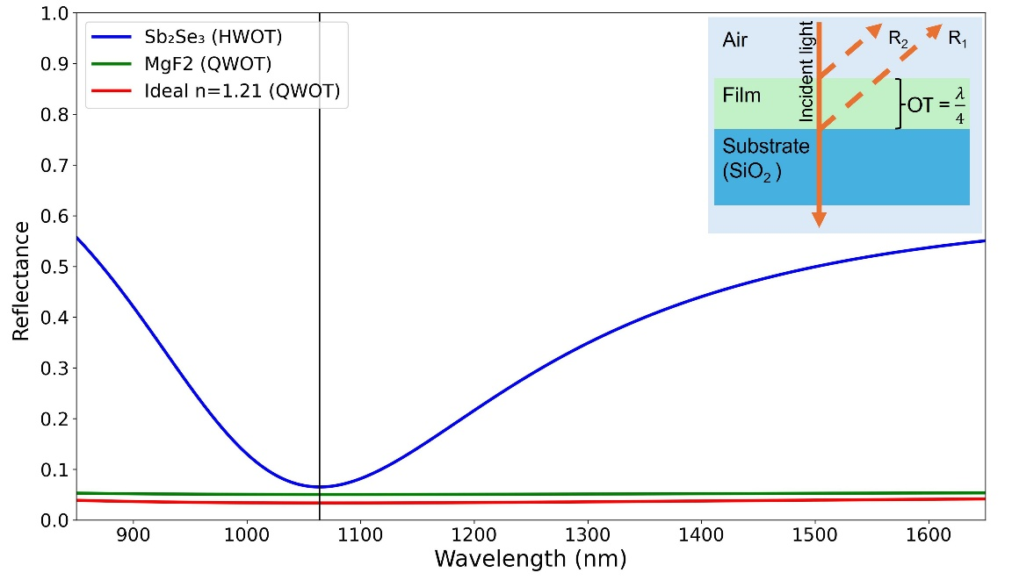
Fig. 2. Reflectance of a single-layer designs with different film index. At 1064 nm (black, vertical line), HWOT-thick Sb₂Se₃ (blue) has the highest reflectance R = 6.5%. QWOT-thick MgF₂ (green) R = 5.0%. An ideal QWOT-thick film with n_{ideal} = 1.21 (red) has the lowest reflectance, R = 3.4%. The QWOT-thick structure is shown in the top right corner.

2.3 Multilayer antireflection design
Two-layer design with each layer thickness being QWOT (Q/Q design) is also be used to create antireflection conditions. The Fresnel reflection coefficient r from Eq. 7 can be expanded to
$r=\frac{n_{a}-n_{r2}}{n_{a}+n_{r2}}=\frac{n_{a}-(\frac{n_{f2}^{2}}{n_{r1}})}{n_{a}+(\frac{n_{f2}^{2}}{n_{r1}})}=\frac{n_{a}-(\frac{n_{f2}^{2}}{n_{f1}^{2}/n_{s}})}{n_{a}+(\frac{n_{f2}^{2}}{n_{f1}^{2}/n_{s}})}$, (11)
where n_{f} begins from the substrate side and increases toward the air side (n_{s} / n_{f1} / n_{f2} / n_{a}), n_{r2} is the effective reflectance index of the entire structure [23], and n_{r1} is the effective reflectance index of only the substrate (n_{s}) and bottom film (n_{f1}). Similar to Eq. 7, the antireflection condition of the two-layer design occurs when n_{a} = n_{r2} or
$n_{a}=\frac{n_{f2}^{2}}{n_{f1}^{2}/n_{s}}$, (12)
$\frac{n_{a}}{n_{s}}=\frac{n_{f2}^{2}}{n_{f1}^{2}}$. (13)
From Eq. 13, it can be seen that the refractive index of the top film must be smaller than the bottom film (n_{f2} < n_{f1}). For example, at λ₀ = 1064 nm, if we use the same SiO₂ substrate (n_{s} = 1.46) and Sb₂Se₃ as the bottom film (n_{f1} = 3.37), the ideal refractive index of the top film (n_{f2}) is 2.78. A commonly used material with the closest refractive index is TiO₂ (n_{TiO2} = 2.31) [26]. Compared to the single-layer Sb₂Se₃ design, the two-layer Sb₂Se₃/TiO₂ design has a lower reflectance at 1064 nm and wider AR region, as shown in Fig. 3. Another way to create a two-layer AR condition is to fix the two film refractive indices and vary the thickness of each film, as explained in Chapter 5.2 of [23]. However, this method narrows the spectral range of the antireflection region.
A three-layer design with an HWOT-thick film in the middle (Q/H/Q) requires refractive index orderings of n_{s} < n_{f1} < n_{f2} and n_{f2} > n_{f3} > n_{a} for antireflection properties. The middle layer (n_{f2}) acts as an absentee layer when the incident wavelength is the same as the reference wavelength (λ = λ₀). The reflection coefficient is equal to
$r=\frac{n_{a}-n_{r3}}{n_{a}+n_{r3}}=\frac{n_{a}-\left(\frac{n_{f3}^{2}}{n_{r2}}\right)}{n_{a}+\left(\frac{n_{f3}^{2}}{n_{r2}}\right)}$. (14)
Because the middle film layer (n_{f2}) is HWOT thick, it behaves as an absentee layer [23, 27]. So n_{r2} = n_{r1}, and Eq. 14 becomes:
$r=\frac{n_{a}-\left(\frac{n_{f3}^{2}}{n_{r1}}\right)}{n_{a}+\left(\frac{n_{f3}^{2}}{n_{r1}}\right)}=\frac{n_{a}-\left(\frac{n_{f3}^{2}}{n_{f1}^{2}/n_{s}}\right)}{n_{a}+\left(\frac{n_{f3}^{2}}{n_{f1}^{2}/n_{s}}\right)}$, (15)
and a three-layer antireflection condition occurs when
$\frac{n_{a}}{n_{s}}=\frac{n_{f3}^{2}}{n_{f1}^{2}}$. (16)
The refractive index ratio of top and bottom films is similar to that of the two-layer design. As an example, if the bottom layer (n_{f1}) is Sb₂Se₃ (QWOT), then the ideal top layer (n_{f3, ideal}) is 2.78, so TiO₂ (n_{TiO2} = 2.31) is used again. The middle layer needs to have the highest refractive index, so Silicon (Si) is used (n_{Si} = n_{f2} = 3.55) [28]. As shown in Fig. 3, the reflectance of the three-layer design (yellow) at wavelengths further from λ₀ (i.e., 1400 nm and longer) is lower than that of a single (blue) or two-layer design (green). This is a benefit of adding an extra absentee layer in the middle, it contributes to a broader operating bandwidth [27].
Instead of placing the PCM as the bottom film layer, Sb₂Se₃ can be moved to the middle so that the selection of ideals n_{f1} and n_{f3} is easier. The bottom layer could be Si₃N₄ (n_{f1} = 2.00) [29] and the ideal top layer calculated using Eq. 16 has n_{f3} = 1.65, which Al₂O₃ has the closest refractive index (n_{Al2O3} = 1.62) [26]. These designs are shown in Fig. 3, where the reflectance of the designs with Sb₂Se₃ deposited directly on top of the substrate, i.e., single-layer, two-layer, and three-layer designs, are ~6.5%. But the three-layer design with Sb₂Se₃ placed in the middle (n_{f2} = Sb₂Se₃) has a reflectance of 3.4%, which is the same value as that of an ideal single-layer design (3.4%). This improvement can be explained by the selection of n_{f1} and n_{f3} which are closer to ideal values.

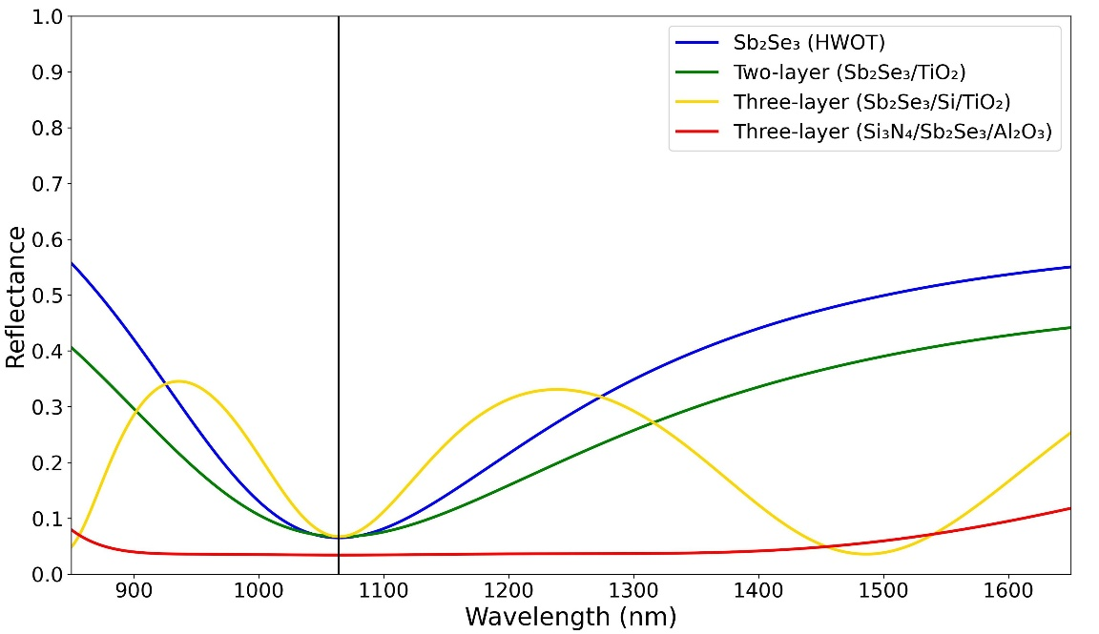
Fig. 3. Reflectance comparison of a single-layer and multi-layer designs. At 1064nm (black vertical line), the single-layer, two-layer and three-layer designs with Sb₂Se₃ as bottom layer (n_{f1}) have similar reflectance at 6.5–6.7%. However, three-layer design with Sb₂Se₃ as middle layer (n_{f2}) has the lowest reflectance at 3.4%.

2.4 Long-pass edge-filter design
In all previous examples, the reflectance after Sb₂Se₃ transitioned to the crystalline phase have not yet been considered. In addition to low reflectance in the ON mode, transmittance tuning also required high optical contrast between the two modes. Figure 4 shows a reflectance comparison between Sb₂Se₃ in amorphous (solid) and crystalline (dotted) phases, which represent the devices in the ON and OFF modes, respectively. These designs are the same as those described in Fig. 3. The single-layer design exhibited the highest reflectance contrast of 55.0% (Fig. 4a, blue). But for the three-layer design with Sb₂Se₃ as the middle layer (Fig. 5b, red), even though it has the lowest reflectance in amorphous phase (3.4%), its crystalline phase reflectance only increased to 14.8%, which results in a reflectance contrast of only 11.4%.
Another antireflection design is called an edge-filter design, which has high reflection in the region surrounding the reference wavelength λ₀ but exhibits strong antireflection (AR) properties outside of this region. The filter can be designed such that the desired operating wavelength is in the AR region, at the edge of these two regions. When phase transition occurs and the device changes to OFF mode, the reflectance profile will be shifted and the operating wavelength will be inside the high-reflection region instead. The edge filter design is composed of QWOT-thick high refractive index (H) and low refractive index (L) layers deposited symmetrically on top of each other in a structure called a unit cell (U). Only one side of the AR region have a stable reflectance profile, determined by the unit cell structure; long-pass structure $\left(\frac{H}{2}L\frac{H}{2}\right)$ has a stable AR at wavelengths longer than the high-reflection region, but the short-pass structure $\left(\frac{L}{2}H\frac{L}{2}\right)$ has a stable AR at shorter wavelengths, the 1/2 denotes a layer with half-QWOT thickness. The number of unit cells could be one or more, and this number is directly correlated to the steepness of regions’ edges. To minimize the thickness of the device, a long-pass design is preferred because λ₀ is at a shorter wavelength, so optical and physical thickness will be thinner. The spectral width of the high-reflection region is directly correlated with the differences between the H and L refractive indices.
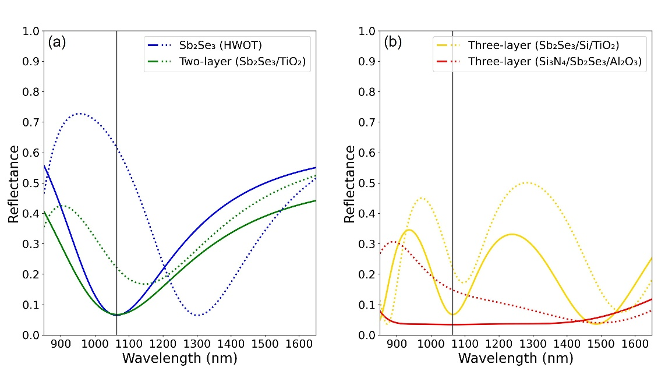
Fig. 4. Reflectance of the designs shown in Fig. 3 before (solid) and after (dotted) phase transition. The single-layer design has the highest reflectance contrast (ΔR = R_{a} – R_{c}) of 55.0%.

Figure 5 shows five long-pass edge filter designs with number of unit cells (N) from 1 to 6. These designs used Sb₂Se₃ as the H layer and MgF₂ as the L layer; the reference wavelength is changed to λ₀ = 740 nm. When these devices are in the amorphous phase (Fig. 5a), the wavelengths surrounding the operating wavelength (λ = 1064 nm) are in the AR region, when they are switched to crystalline phase (Fig. 5b) the wavelength of interest is in the high-reflection region. These shifts cause the reflectance contrast to be higher than any previous designs, with more than 90% contrast for four, six and eight unit-cell designs. It can also be seen that increasing N makes the region’s edge steeper, but the improvement from 4 to 6 unit cells is smaller than from 1 to 2 unit cells.

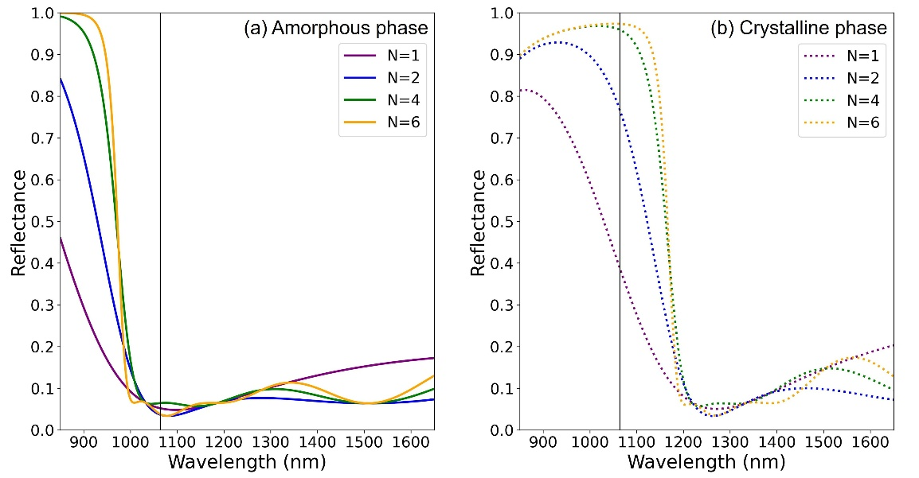
Fig. 5. Reflectance comparison of long-pass edge-filter designs with increasing number of unit cells (N). (a) When devices are in amorphous phase (ON mode), the wavelength of interest (black vertical line) is in the AR region. (b) When devices are changed to crystalline phase (OFF mode), the wavelength of interest is in the high-reflection region.
- Methods
3.1 Simulation of optical performances
In this study, we use the transfer matrix method (TMM) with the Fresnel equation to calculate the transmittance, absorptance, and reflectance of each design. Although the computations are based on [23], other simulation software such as COMSOL, or OpenFilters [30] can also be used. We use 3-mm thick silica (SiO₂) as the substrate (n_{s} = 1.47) [24]. The high-index layers (H) are Si [28], TiO₂ [26], and Si₃N₄ [29], their refractive indices at 1064 nm are 3.56, 2.31, and 2.00, respectively. The low-index layers (L) are Al₂O₃ [26], SiO₂ and MgF₂ [25], and their refractive indices are 1.62, 1.45, and 1.38, respectively. All the aforementioned refractive index datasets can be found on refractiveindex.info website [31]. However, because antimony triselenide (Sb₂Se₃) is a relatively new material in this field, its dataset cannot be found there, we instead used the Sb₂Se₃ dataset from Delaney, et al. [18]. The refractive index of air is set to n_{a} = 1.0 across the spectrum, and the backside reflection from the substrate-air layer is calculated. The incident angle is 0°, and light is transverse electric (TE) polarized unless stated otherwise.
All the designs are intended to operate at a wavelength center around 1064 nm. The design comparison is between single-layer, two-layer, three-layer, and edge-filter designs. The goal is to design a device with a high transmission contrast ΔT between the two phases of Sb₂Se₃ by minimizing the reflectance in the ON mode and maximizing R in the OFF mode.
3.2 Simulation of optical endurance and stability under large phase switching cycles
Experimental studies have demonstrated that Sb₂Se₃ can has phase switching cycles with minimal degradation of its optical contrast and maintain a low-loss, reversible modulation in the order of 10⁶ phase switching cycles [21]. Even so, Sb₂Se₃ still exhibits a slight complex refractive index drift due to structural relaxation and cumulative thermal damage. Accounting for these variations is essential for ensuring long-term reliability and precision in high-endurance photonic applications [21, 22]. To account for this, the complex refractive index (ñ) can be rewritten as
${\tilde{n}}_{p}\left(C\right)=n_{p}\left(C\right)+ik_{p}\left(C\right)$, (17)
where C is the number of the phase switching cycle. The real part of the refractive index (n) is described by an exponential relaxation towards a saturated value such that
$n_{p}\left(C\right)=n_{p,∞}-\left(n_{p,∞}-n_{p,0}\right) \exp^{-α_{p}C}$, (18)
where n_{p,∞} is the asymptotic refractive index after many cycles, n_{p,0} is the refractive index at the first cycle (obtained from ellipsometry or literature data), and α_{p} is the drift coefficient per cycle of phase p [18, 32].
Meanwhile, the imaginary part k can be approximated from a linear growth as
$k_{p}\left(C\right)=k_{p,0}(1+β_{p}C)$, (19)
where k_{p,0} is the initial loss, and β_{p} is the loss growth coefficient. Parameter β_{p} is the relative loss per cycle of phase p [21, 33]. The model from Eq. (19) is adopted in this work, they are consistent with experimental trends and with general PCM endurance theory, providing a practical way to assess contrast degradation and threshold drift of PCM-based devices over large cycles [18, 21, 32, 33].
Optical endurance can be quantified using the following metrics; percentage transmitting contrast degradation (D_{pct}) and insertion loss (IL). Transmittance contrast degradation is defined as the change in transmittance contrast after N cycles:
$D_{pct}(C)=\frac{ΔT(C)-ΔT_{0}}{ΔT_{0}}$, (20)
where ΔT₀ is the transmittance contrast between the amorphous and crystalline phases in the initial cycle C = 0 (ΔT₀ = T_{a}(0) - T_{c}(0)). A negative D_{pct} indicates a decreasing contrast.
The insertion loss (IL) of the device at cycle C compares the high-transmittance amorphous phase after the initial cycle:
${IL}_{dB}\left(C\right)=10 log\left[\frac{T_{a}(C)}{T_{a}(0)}\right]$. (21)
A increasing IL_{dB}(C) indicates increasing loss, which is typically driven by the linear growth of the imaginary index k_{p}(C) and by detuning of the resonance due to drift in n_{p}(C).
- Results & Discussions
4.1 Optical properties of 1064-nm optical filters
The design architectures, number of layers, total thickness of Sb₂Se₃, overall design thickness, transmittance in each mode, and transmittance contrast (ΔT = T_{a} - T_{c}) of each design are shown in Table 1. The operating wavelength is 1064 nm, and the reference wavelength λ₀ is 1064 nm for single-layer, two-layer, and three-layer designs; however, λ₀ is 740 nm for edge-filter designs. The results show that only single-layer and edge-filter designs with at least two-unit cells (N ≥ 2) have a ΔT higher than 50%, with 7-unit-cell design having the highest ΔT of 95.1%. However, while there is only marginal improvement in ΔT when N exceeds 3, the Sb₂Se₃ layer thickness and the overall device thickness increase drastically; for example, ΔT improves by 2% in N = 4 design when compared to N = 3 design, the thickness increases by 33.3%, but when comparing N = 5 to N = 4 designs, ΔT increases by only 0.6%, and the device needs to be 25.0% thicker. It is important to note that increasing unit cell numbers also require more Sb₂Se₃ material, less Sb₂Se₃ used also has the benefit of minimizing the energy required for phase transition.
Table 1. Designs of 1064-nm Sb₂Se₃-based optical filter. Transmittance is calculated at λ = 1064 nm. Single, two, and three-layer designs all have λ₀ = 1064 nm, but all edge-filter designs have λ₀ = 740 nm.
Design | Layout | Number of layers | SbSe used (nm) | Device thickness (nm) | T (ON) (%) | T (OFF) (%) | ΔT (%)
Single-layer | SbSe | 1 | 157.9 | 157.9 | 93.5 | 37.2 | 56.3
Two-layers | SbSe/TiO | 2 | 78.9 | 194.1 | 93.3 | 76.9 | 16.4
Three-layers | SbSe/MgF/TiO | 3 | 78.9 | 580.3 | 93.3 | 76.9 | 16.4
Three-layers | SiN/SbSe/AlO | 3 | 157.9 | 455.7 | 96.6 | 83.3 | 13.3
Edge filter | $${(\frac{SbSe}{2}/MgF/\frac{SbSe}{2})}^{1}$$ | 3 | 48.5 | 182.5 | 94.1 | 54.3 | 39.8
Edge filter | $${(\frac{SbSe}{2}/MgF/\frac{SbSe}{2})}^{2}$$ | 5 | 97.0 | 365.0 | 95.0 | 16.3 | 78.7
Edge filter | $${(\frac{SbSe}{2}/MgF/\frac{SbSe}{2})}^{3}$$ | 7 | 145.5 | 547.6 | 94.8 | 4.0 | 90.8
Edge filter | $${(\frac{SbSe}{2}/MgF/\frac{SbSe}{2})}^{4}$$ | 9 | 194.0 | 730.1 | 93.7 | 0.9 | 92.8
Edge filter | $${(\frac{SbSe}{2}/MgF/\frac{SbSe}{2})}^{5}$$ | 11 | 242.6 | 912.6 | 93.6 | 0.2 | 93.4
Edge filter | $${(\frac{SbSe}{2}/MgF/\frac{SbSe}{2})}^{6}$$ | 13 | 291.1 | 1,095.1 | 94.5 | 0.0 | 94.5
Edge filter | $${(\frac{SbSe}{2}/MgF/\frac{SbSe}{2})}^{7}$$ | 15 | 339.6 | 1,277.7 | 95.1 | 0.0 | 95.1

In the edge-filter designs, the transmittance in the OFF mode decreased with increasing N, as previously shown in Fig. 5b, with N ≥ 6 designs having zero transmittance. This is because N correlates to the total Sb₂Se₃ thickness and Sb₂Se₃ in the crystalline phase has a small, but not zero, extinction coefficient (k_{cry}(1064) = 0.0097), therefore, light is absorbed by each Sb₂Se₃ layer. For reference, k_{Sb2Se3} is ~10² smaller than that of other PCMs such as GST (k_{GST, cry} = 2.4540) or VO₂ (k_{VO2, metallic} =1.4580). These are illustrated in Fig. 6, where the transmittance contrast (ΔT) of the single-layer and edge-filter designs with N ≤ 6 are shown. Even though edge-filter designs with N from 3 to 6 (cyan, green, yellow, and orange, in order) have similar ΔT at the operating wavelength (black vertical line), the bandwidth of high-ΔT region is wider in design with larger unit-cell numbers. This property should be considered if the filter is intended to be used in a broad spectrum.

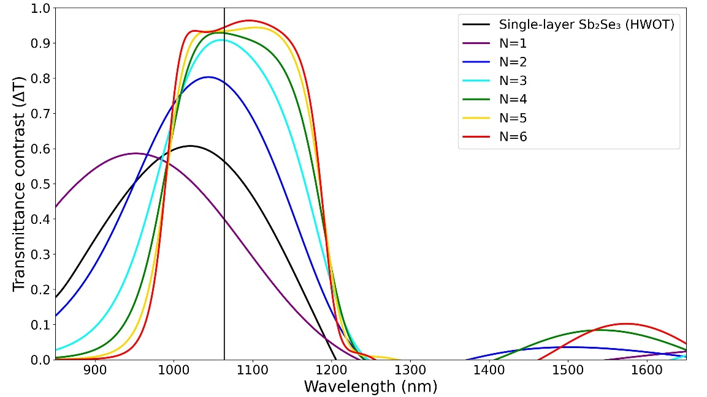
Fig. 6. Transmittance contrast (ΔT) of a single-layer and edge-filter designs with different number of unit cells (N). The vertical black line indicates the interested 1064 nm wavelength.

Two other properties that might need to be considered are the optical performance at varying incident angles and the polarization mode of the incident light (TE or TM). Figure 7 shows 4-unit-cell and 5-unit-cell designs with incident angles ranging from 0° to 90°, and with polarization in TE (Fig. 7a and 7c) and TM (Fig. 7b and 7d). For both TE and TM polarized light, ΔT remains higher than 90% from 0° to ~30°, but TM polarization causes the high-ΔT region to blueshift significantly at higher incident angle. The spectral widths of the high-ΔT region in both designs are comparable, but the 5-unit-cell design has a higher ΔT across the spectrum, which indicates a better broadband, wide-angle, tunable optical device.
With the reasons given above, we decided that a 5-unit-cell, long-pass edge-filter design (Fig. 6, yellow) has the best compromise between high optical performances, device size, and complexity. This design has a broadband transmittance contrast between the amorphous (ON mode) and the crystalline phases (OFF mode), and the FWHM of high-ΔT region is 197.0 nm. This design is used as an example in the following sections.

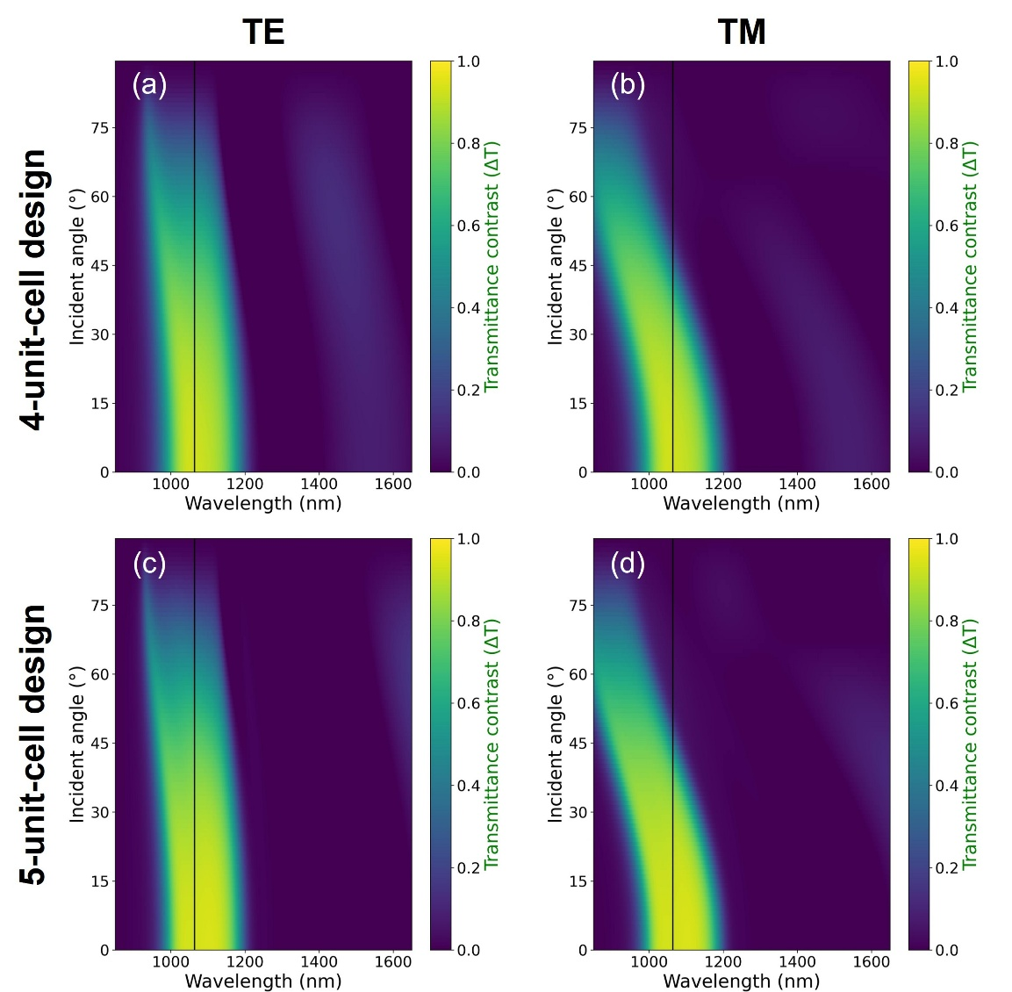
Fig. 7. Transmittance contrast at different incident angles and wavelengths of 4-unit-cell and 5-unit-cell edge-filter designs. The polarizations of incident light are TE (a, c) and TM (b, d).

4.2 Endurance simulation of 1064-nm optical filters( check endurance of edge-filter.)
Endurance simulation at 1064 nm of the single-layer Sb₂Se₃, and 5-unit-cell edge-filter designs demonstrated that all three resonant optical filters remain operational up to 1.5×10⁶ phase switching cycles, with design-dependent degradation of their transmittance metrics. For the single-layer design, both the amorphous (T_{a}) and crystalline phases transmittance (T_{c}) decrease modestly (Fig. 8a). And both the corresponding percentage transmittance contrast degradation (D_{pct}) and insertion loss (IL) also decrease with cycling number, as shown in Fig. 8c and 8e, respectively. For the 5-unit-cell edge-filter design, the T_{a} and insertion loss decrease at a rate slower than in the single layer design, but its T_{c} increased slightly. This causes the contrast degradation to become three times larger (Fig. 8d)
These simulation results confirm that design with multiple layers of Sb₂Se₃ have comparable transmittance endurance to a single-layer Sb₂Se₃. The edge-filter designs have a stronger field confinement so they exhibit less insertion loss when compared to single-layer design, their larger D_{pct} are attributed to fact that their T_{c} become higher with cycle numbers. Overall, the edge-filter designs still have a higher transmittance contrast and a lower insertion loss after 1.5×10⁶ cycles.
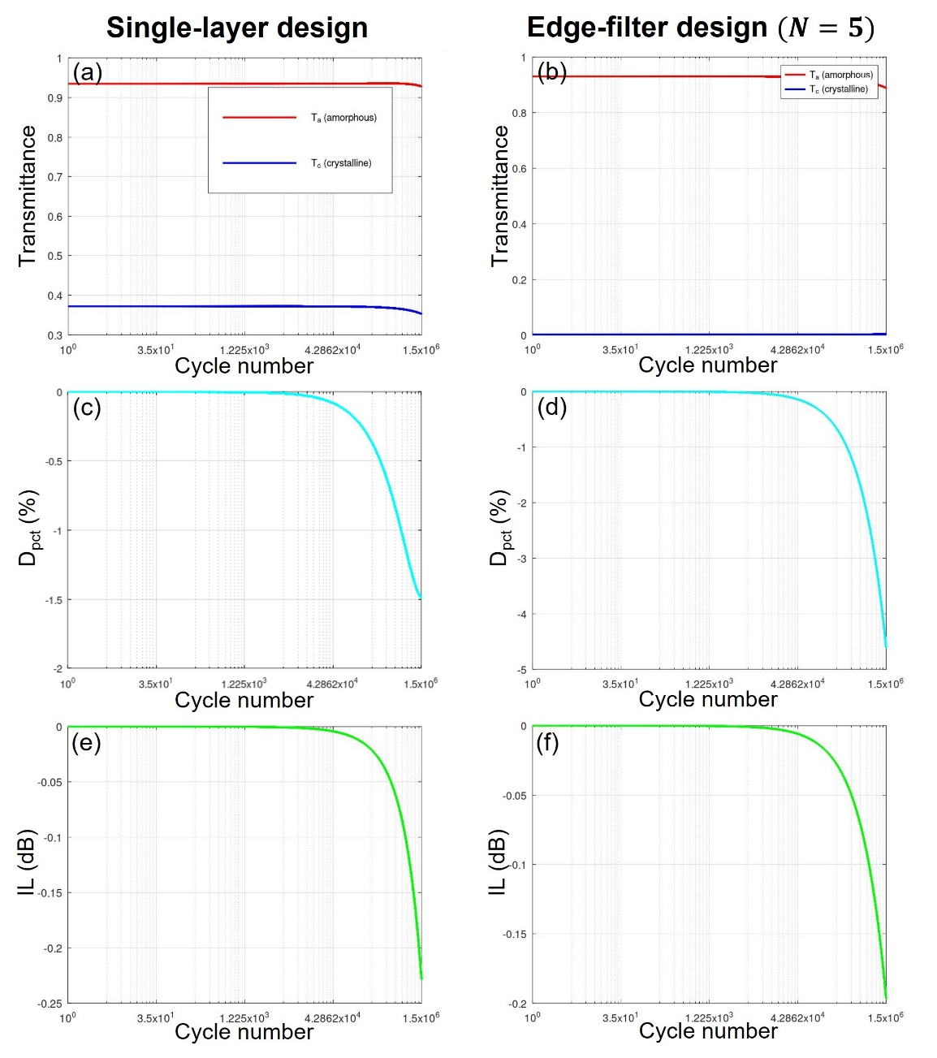
Fig. 8. Optical endurance at 1064 nm of the single-layer, and 5-unit-cell edge-filter designs after 1.5×10⁶ phase-switching cycles. (a,b) Transmittance in amorphous (red) and crystalline phases (blue). (c,d) The percentage transmittance contrast degradation relative to the initial value. (e,f) Insertion loss in amorphous phase, expressed in dB. Note a different y-axis scales.

4.3 Transmittance tunability and optimization.
Edge-filter designs have multiple layers of Sb₂Se₃ which complicates the phase switching setup. When laser-induced heating is used as a switching method, the phase transition of every Sb₂Se₃ layer does not occur simultaneously and the transmission changes gradually. This effect is shown in the optical limiter of Sarangan, et al. [3] Their device has a similar long-pass edge-filter design ${\left(\frac{H}{2}L\frac{H}{2}\right)}^{4}$ but the H layers are GST instead of Sb₂Se₃, and the L layers are SiO₂ instead of MgF₂. Their experimental results showed that the phase switching of GST layers occurs layer-by-layer in an order that is determined by the changes in the optical field distribution and thermal crosstalk between layers, which does not necessarily start from the air -side to the substrate-side. However, our device is intended to be used as a transmittance-tunable filter that does not require a fast switching speed; therefore, electrical heating is also available as an alternative phase switching method. The ability to manually control the phase of each Sb₂Se₃ layer enables the filter to have multiple transmittance values. Using the 5-unit-cell edge-filter design described in Table 1, which consists of 11 layers of Sb₂Se₃ and MgF₂ (six layers of Sb₂Se₃), there would be a total of 2⁶ configurations for the Sb₂Se₃ phases. Figure 9 highlights some of these configurations; the legend denotes Sb₂Se₃ in the amorphous (a) or crystalline phase (c), and the ordering from left to right is from the substrate to the air side (f₁ to f₆). With the correct phase configuration, the transmittance can be gradually reduced from peak of 93.4% to 0.0%.

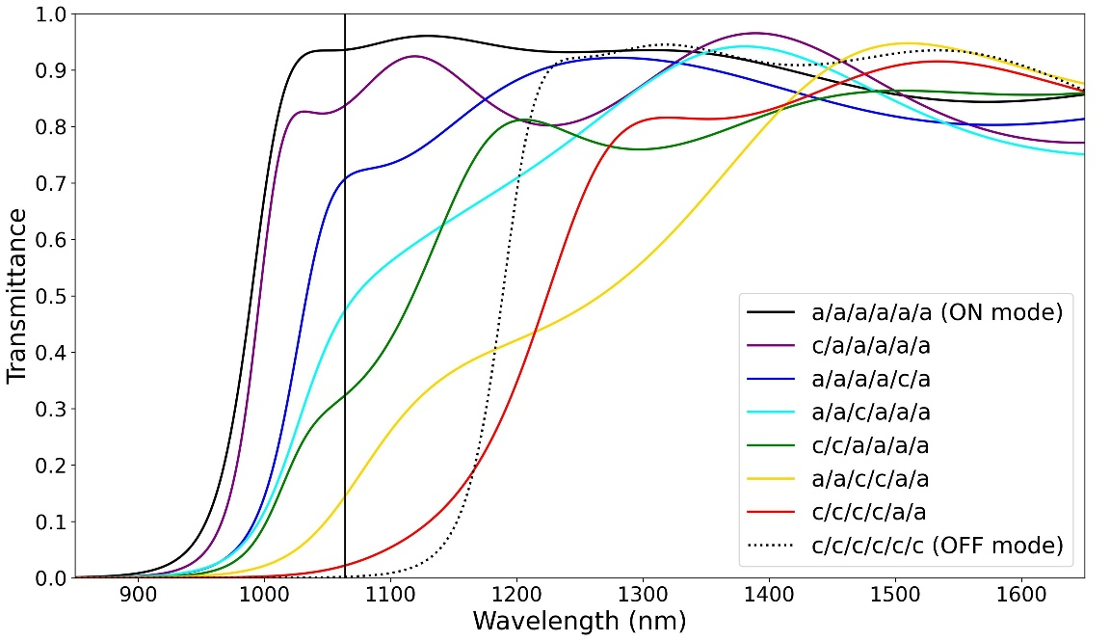
Fig. 9. Transmittance of the five-unit-cell edge-filter design in 8 different configurations. Each Sb₂Se₃ layer is in amorphous (a) or crystalline (c) phases, and the layout ordering from left to right is substrate-side to air-side.

The peak transmittance contrast of each design shown in Fig. 6 does not always correspond to the desired operating wavelength of 1064 nm. This is explained by the arbitrary selection of the reference wavelength in edge-filter designs. So, an optimization algorithm can be used to improve the optical performance. A simple merit function found in OpenFilters [30] is used in this example. The optimization goal for the 5-unit-cell edge-filter design is to have a transmittance value of at least 97% from 1000 to 1200 nm at intervals of every 20 nm. The optimization took less than 5 s, and the new design now required 304.2 nm of Sb₂Se₃, 25% more than the original design, but the overall thickness is now 845.6 nm, 7% less than the original, the thickness of each layer is shown in Table 2. Figure 10a shows the transmittance of the original (green) and optimized designs (blue) in the amorphous (solid) and crystalline phases (dotted). Overall, the optimized design has a higher transmittance in the desired 1000 to 1200 nm spectrum, but the spectral profile has been blue shifted by a small amount. The transmittance contrast at 1064 nm (Fig. 10b) of the optimized design is also higher, 95.8%, compared to 93.4% of the original. The transmittance contrast FWHM also extended slightly to 207.4 nm (original: 197.0 nm).
Table 2. Thickness of each layer before and after optimization. Sb₂Se₃ and MgF₂ layers units are in nm.
Design | SiO₂ | Sb₂Se₃ | MgF₂ | Sb₂Se₃ | MgF₂ | Sb₂Se₃ | MgF₂ | Sb₂Se₃ | MgF₂ | Sb₂Se₃ | MgF₂ | Sb₂Se₃
Original | 3 mm | 24.3 | 134.0 | 48.5 | 134.0 | 48.5 | 134.0 | 48.5 | 134.0 | 48.5 | 134.0 | 24.3
Optimized | 3 mm | 46.1 | 67.5 | 59.3 | 148.1 | 55.0 | 89.3 | 50.0 | 145.3 | 63.3 | 91.2 | 30.5

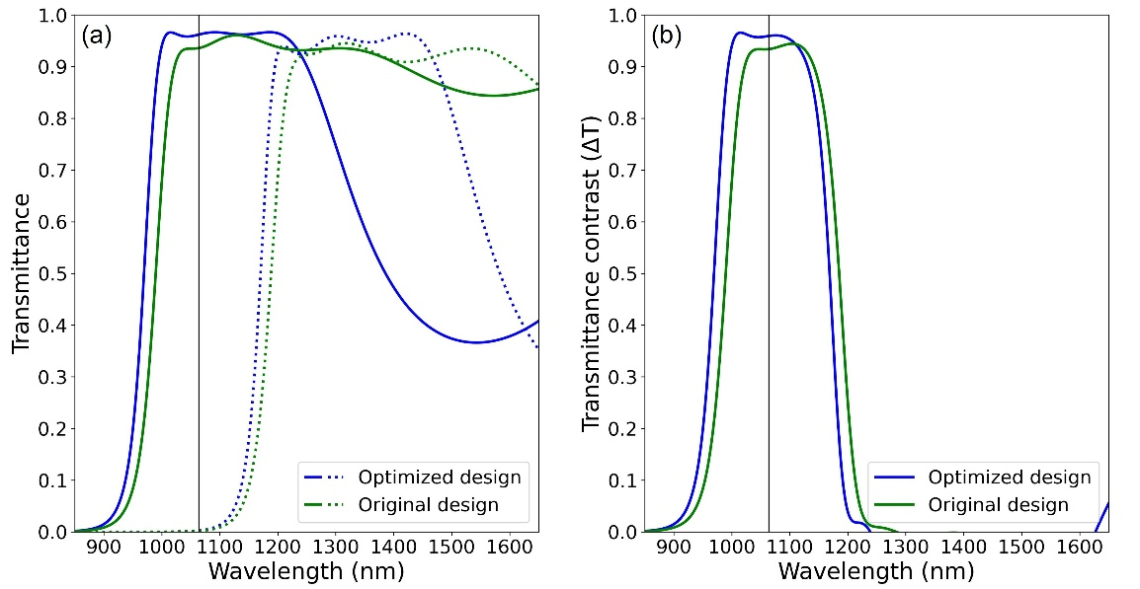
Fig. 10. Transmittance comparison of 5-unit-cell edge-filter design before (green) and after (blue) optimization. (a) The transmittance in ON mode (solid) and OFF mode (dotted). (b) The transmittance contrast (ΔT). An optimized design has higher optical performance from 900 to 1200 nm, but the high- ΔT region has been blueshifted by a small amount.

- Conclusions
We have shown that Sb₂Se₃ is a suitable PCM for zero-absorption, broadband transmittance-tunable optical filter operating around 1064 nm wavelength. The 5-unit-cell long-pass edge-filter design has the best compromise between optical performance, size, and design complexity. This design required six Sb₂Se₃ layers and five MgF₂ layers and is 912 nm thick. Transmittance at 1064 nm in the ON mode is 93.4% and 0.2% in OFF mode, a contrast of 93.4% with around 200 nm FWHM. Simulations show that after 1.5×10⁶ phase switching cycles, the transmittance contrast degradation and insertion loss in ON mode is still within acceptable ranges. The multilayer nature of edge-filter design enables the gradual modulation of transmittance by changing the phase of each Sb₂Se₃ layer. We also show that a quick and simple optimization algorithm can increase the optical performance from 900-1200 nm.
Funding: School of Science, King Mongkut’s Institute of Technology Ladkrabang (KMITL) (CN-1-2568-010).
Acknowledgment. The authors greatly appreciate the discussion, grammar and format suggestions from Nathan Hagen, Center for Optical Research and Education, Utsunomiya University, Japan.
Disclosures: The authors declare no conflicts of interest.
Data availability. Data underlying the results presented in this paper may be obtained from the corresponding author upon a reasonable request.
Declaration of generative AI and AI-assisted technologies in the manuscript preparation process. The authors used Gemini for Python codes debugging, Gemini and Paperpal Preflight to check the grammar of the manuscript, and Consensus was used to help with the initial literature review. After using these tools, the authors reviewed and edited the content as needed and take full responsibility for the contents published.
References
1. K. Matuszek, et al., "Phase Change Materials for Renewable Energy Storage at Intermediate Temperatures," Chemical Reviews 123, 491–514 (2023).
2. R. Matos and N. Pala, "A Review of Phase-Change Materials and Their Potential for Reconfigurable Intelligent Surfaces," Micromachines 14, 1259 (2023).
3. A. Sarangan, et al., "Broadband Reflective Optical Limiter Using GST Phase Change Material," IEEE Photonics Journal 10, 1–9 (2018).
4. K. Aryana, et al., "Optical and thermal properties of Ge2Sb2Te5, Sb2Se3, and Sb2S3 for reconfigurable photonic devices [Invited]," Opt. Mater. Express 13(2023).
5. W. Jia, et al., "Unique prospects of phase change material Sb2Se3 for ultra-compact reconfigurable nanophotonic devices," Opt. Mater. Express 11, 3007–3014 (2021).
6. S. Blundell, et al., "Ultracompact Programmable Silicon Photonics Using Layers of Low-Loss Phase-Change Material Sb2Se3 of Increasing Thickness," ACS Photonics 12, 1382–1391 (2025).
7. C. Wan, et al., "Ultrathin Broadband Reflective Optical Limiter," Laser & Photonics Reviews 15, 2100001 (2021).
8. A. Tognazzi, et al., "Opto-thermal dynamics of thin-film optical limiters based on the VO2 phase transition," Opt. Mater. Express 13, 41–52 (2023).
9. Y. Li, et al., "An Adaptive Optical Limiter Based on a VO2/GaN Thin Film for Infrared Lasers," Photonics 13, 148 (2026).
10. Y. Zhang, et al., "Broadband transparent optical phase change materials for high-performance nonvolatile photonics," Nature Communications 10, 4279 (2019).
11. H. Li, et al., "Ultra-compact, ultra-low-loss and broadband 2 x 2 nonvolatile optical switch based on Sb(2)Se(3) phase change material," Opt Express 32, 35287–35297 (2024).
12. R. Heenkenda, et al., "Tunable optical filter using phase change materials for smart IR night vision applications," Opt. Express 29, 33795–33803 (2021).
13. D. d. Ceglia, et al., "Tunable Filters for Visible Light Based on Resonant VO2 Planar Thin Films," in 2020 22nd International Conference on Transparent Optical Networks (ICTON), 2020), 1–4.
14. Y.-S. Huang, et al., "Tunable structural transmissive color in fano-resonant optical coatings employing phase-change materials," Materials Today Advances 18, 100364 (2023).
15. M. Cui, et al., "Tunable multi-channel optical filter based on the near-infrared ultralow-loss phase change material Sb2Se3," Opt. Express 34, 7378–7387 (2026).
16. X. Tian and Z.-Y. Li, "An Optically-Triggered Switchable Mid-Infrared Perfect Absorber Based on Phase-Change Material of Vanadium Dioxide," Plasmonics 13, 1393–1402 (2018).
17. C. Liu, et al., "Tunable nonlinear optical absorption in amorphous and crystalline Sb2Se3 thin films," Journal of Alloys and Compounds 791, 753–760 (2019).
18. M. Delaney, et al., "A New Family of Ultralow Loss Reversible Phase‐Change Materials for Photonic Integrated Circuits: Sb2S3 and Sb2Se3," Advanced Functional Materials 30(2020).
19. A. A. Burtsev, et al., "Physical properties’ temperature dynamics of GeTe, Ge2Sb2Te5 and Ge2Sb2Se4Te1 phase change materials," Materials Science in Semiconductor Processing 150, 106907 (2022).
20. X. Chen, et al., "A Review of Integrated Photonic Devices Using Sb2Se3," Advanced Physics Research 4, 2400080 (2024).
21. D. Lawson, et al., "Optical switching beyond a million cycles of low-loss phase change material Sb2Se3," Opt. Mater. Express 14(2023).
22. M. S. Alam, et al., "Fast Cycling Speed with Multimillion Cycling Endurance of Ultra-Low Loss Phase Change Material (Sb2Se3) by Engineered Laser Pulse Irradiation," Advanced Functional Materials 34, 2310306 (2024).
23. A. Sarangan, Optical Thin Film Design, 1st Edition ed. (CRC Press, Boca Raton, 2020).
24. D. Franta, et al., Optical characterization of SiO2 thin films using universal dispersion model over wide spectral range, SPIE Photonics Europe (SPIE, 2016), Vol. 9890.
25. D. Franta, et al., "Universal dispersion model for characterization of optical thin films over wide spectral range: Application to magnesium fluoride," Applied Surface Science 421, 424–429 (2017).
26. S. V. Zhukovsky, et al., "Experimental Demonstration of Effective Medium Approximation Breakdown in Deeply Subwavelength All-Dielectric Multilayers," Physical Review Letters 115, 177402 (2015).
27. Y. Li, et al., "Preparation of mechanically stable triple-layer interference broadband antireflective coatings with self-cleaning property by sol–gel technique," RSC Advances 7, 14660–14668 (2017).
28. D. Franta, et al., "Determination of thicknesses and temperatures of crystalline silicon wafers from optical measurements in the far infrared region," Journal of Applied Physics 123(2018).
29. L. Y. Beliaev, et al., "Optical, structural and composition properties of silicon nitride films deposited by reactive radio-frequency sputtering, low pressure and plasma-enhanced chemical vapor deposition," Thin Solid Films 763, 139568 (2022).
30. S. Larouche and L. Martinu, "OpenFilters: open-source software for the design, optimization, and synthesis of optical filters," Appl. Opt. 47, C219–C230 (2008).
31. M. N. Polyanskiy, "Refractiveindex.info database of optical constants," Scientific Data 11, 94 (2024).
32. L. Martin-Monier, et al., "Endurance of chalcogenide optical phase change materials: a review," Opt. Mater. Express 12, 2145–2167 (2022).
33. Y. Zhang, et al., "Myths and truths about optical phase change materials: A perspective," Applied Physics Letters 118(2021).

